Name:………………………………………………..…. Date:………………………………………………………
Fireworks

What is in a firework?

What you need?
- Periodic Table
- Results table
- Samples of firework chemicals
- Flame test wires
- Distilled water
- Small beaker / test-tube
- Bunsen burner
- Heatproof mat
- Eye protection.

What you do
- Place the Bunsen burner on the heatproof mat. Light the yellow safety flame. Have the gas tap halfway open.
- Put about 20 cm³ distilled water into the test-tube or beaker.
- Turn the Bunsen flame to strong blue flame with the airhole open.
- Dip the wire into the water.
- Dip the wire into the first firework chemical. Only a small amount is needed.
- Hold the wire at the edge of the blue Bunsen flame just above the cone in the centre.
- Look at the colour of the flame. There may also be sparks and the chemical may melt.
- When the colour has gone, put the wire or stick back with the sample dish. Make sure they don't get muddled up.
- Test all the firework chemicals in the same way.
- Write down the colours the chemical make in the flame in the results table and answer the questions.
Safety
Wear eye protection
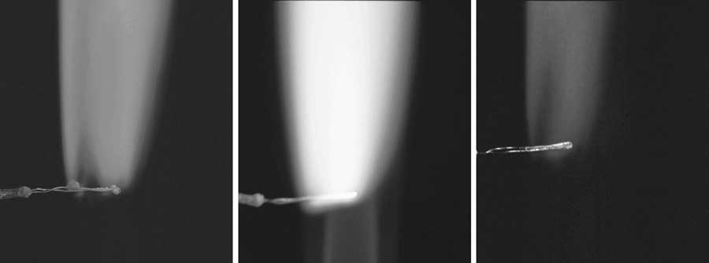

Examples of flame tests

continued on next page


Fireworks
continued from previous page
Results table
Firework chemical | Colour in flame | Other observations

Questions
1. Why do the chemicals make different colours?
……………………………………………………………………………………………………………….………………………………………………………………………………………………………………..……………………………………………………………………………………………………………….………………………………………………………………………………………………………………
……………………………………………………………………………………………………………….
2. Why can the colours not be seen in the chemicals at room temperature?
……………………………………………………………………………………………………………….………………………………………………………………………………………………………………..……………………………………………………………………………………………………………….………………………………………………………………………………………………………………
……………………………………………………………………………………………………………….………………………………………………………………………………………………………………..………………………………………………………………………………………………………………
……………………………………………………………………………………………………………….

